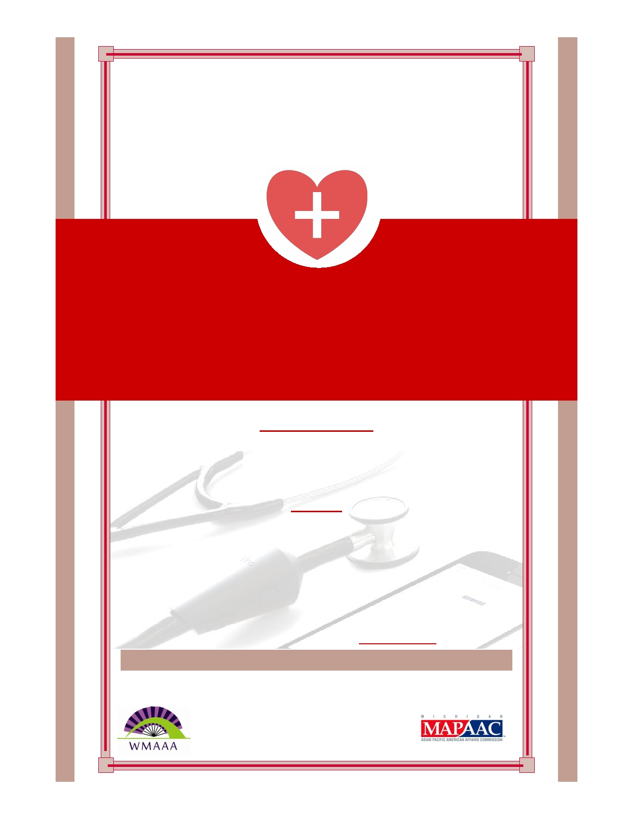
Sunday, September 25th,
2016
Our Lady of LaVang Church, 2019 Porter
St SW, Wyoming MI 49519

HEALTH FAIR AND WORKSHOP
FOR ASIAN COMMUNITIES

1:30PM - 3:30PM
Medical Screening by University of Michigan Asian Medical
Students
Blood Pressure, BMI, Blood Sugar and Cholesterol Panel
2:30PM
Workshop on Health Hazards in Nail Salons For Nail Salon Owners and Nail Technicians
(Open to Owners and Workers)
To be presented by the Michigan Occupational Safety and Health
Administration.
Space is limited; please make reservations for the workshop by
calling Thuhuong Tran at 616-540-7095
Refreshments will be available at this workshop
Hosted by West Michigan Asian American Association and funding support
from Michigan Asian Pacific American Affairs Commission

